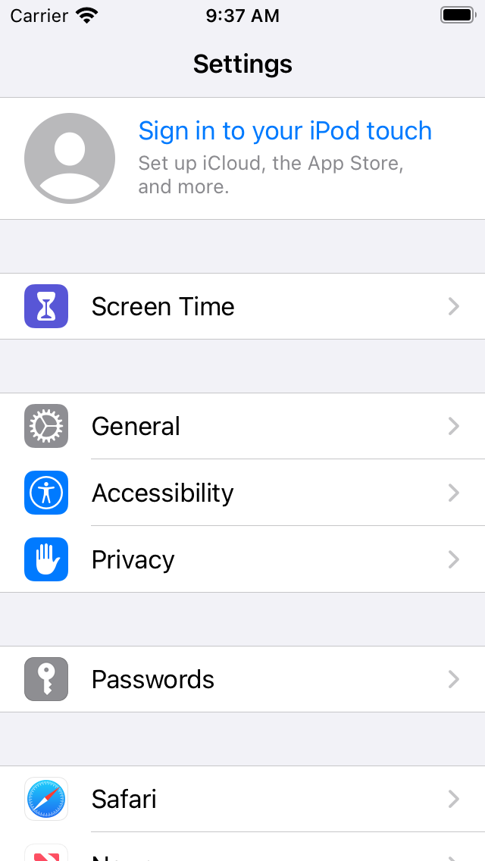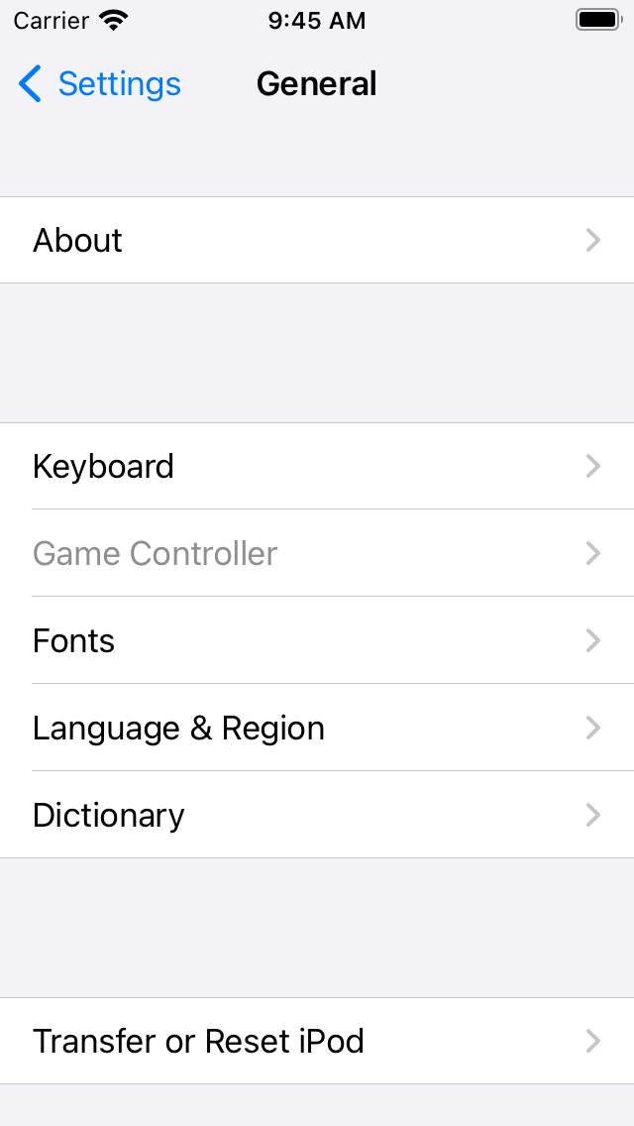

Some views I can see are the

* The apple id profile default picture.
* The table view of screen time, general, etc.
* The labels of screen time and general are showing text to users of what they are.
* Scroll view you can scroll up and down in the settings to see all of the applications.
* In the second screen shot there is a nav bar which navigates you back to the main settings page.

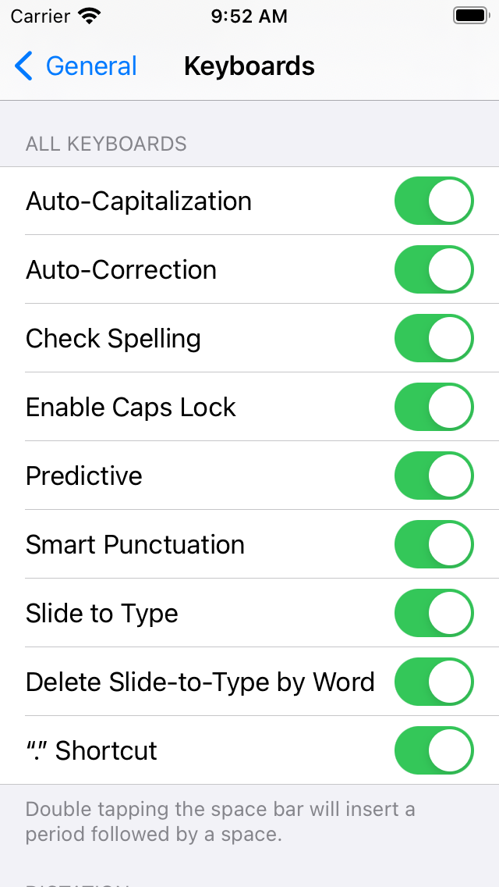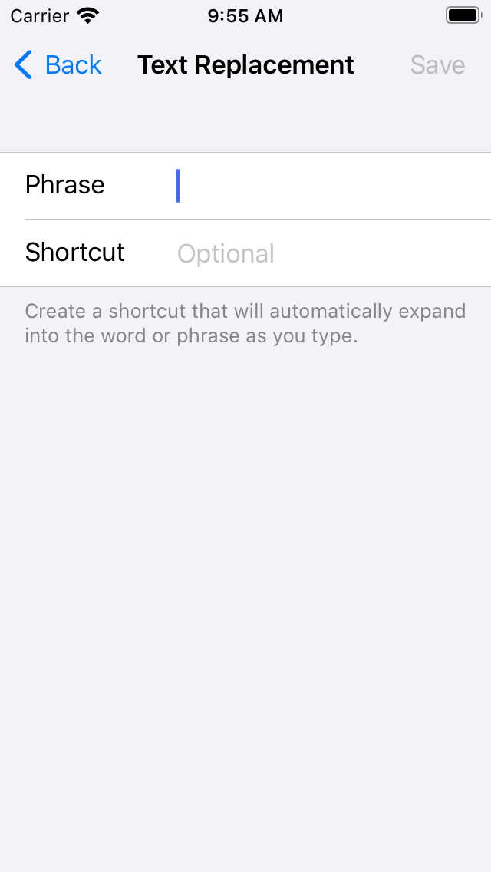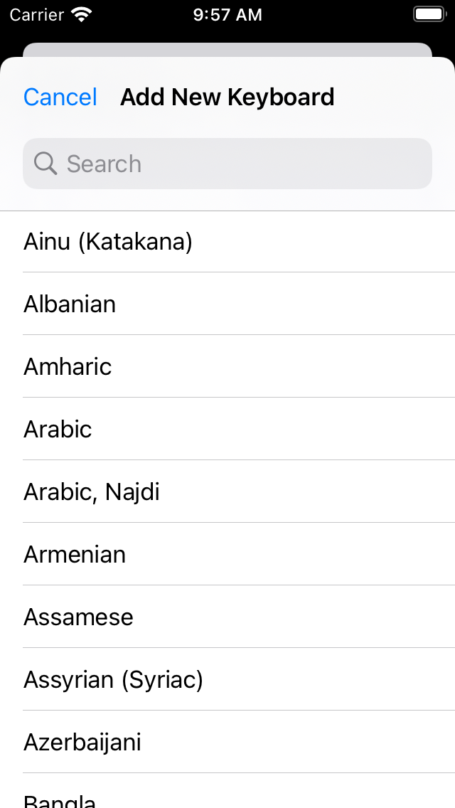

* Here is a control example of switches in settings,
* In the second screen shot there is an example of a textfield control.
* In the third screen shot it shows an example of buttons where you can change what language you can change the keyboard to.

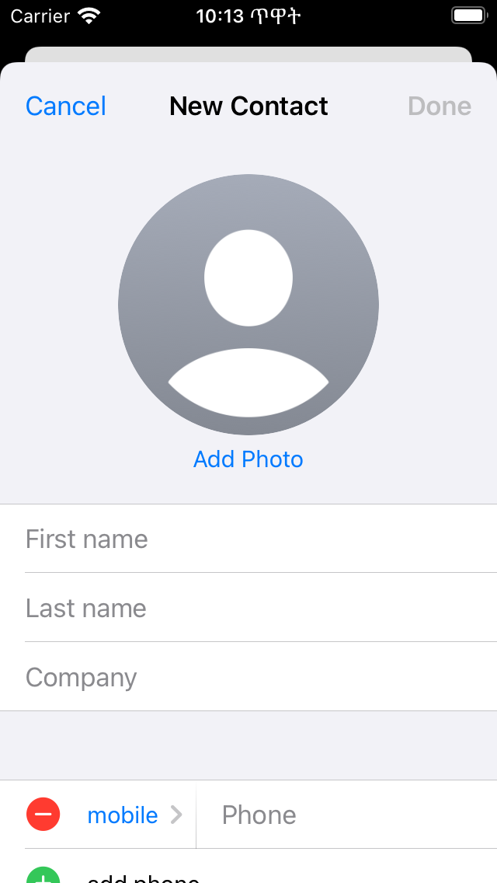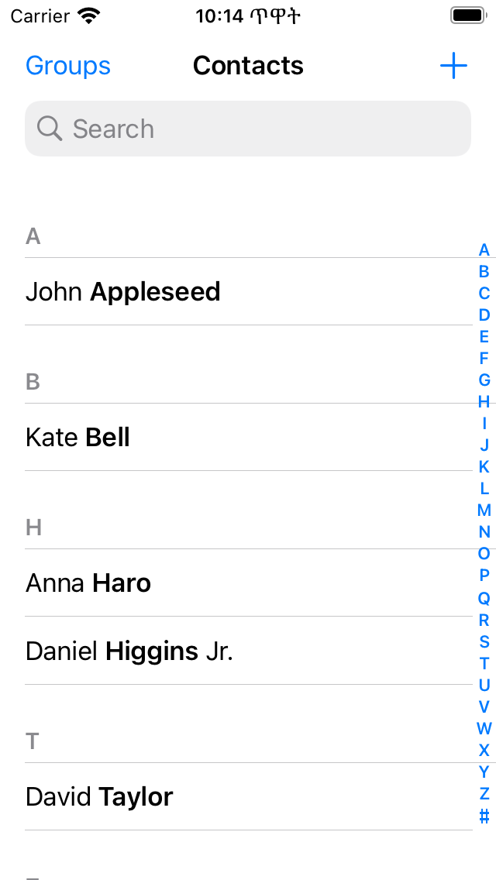

View

1. In the contacts app in the sim you can see there is a label of new contact.
2. There is a default photo for the contact
3. In the main contacts it has a scroll view to look through the contacts
4. It also has a labels of peoples names in contacts

For controls in contacts

1. There is a text box where you can put your name and info.
2. There is a green button to add a new contact
3. There are two buttons in the main view of contacts called groups and the plus button.